Anna Dai (1155004567)
GFN1000 In Dialogue with Nature Tables and figures are not compulsory!
25 Apr 2021
Write the Title Here (Topic 1/2/3)
Here are the general guidelines of term paper. Please double-space the text. Use Times New Roman as the font except for Chinese, for which 宋体 should be used. Use 12 point as the font size. Set the margin of all sides of your paper as 1 inch (2.54 cm). Indent the first line of paragraphs ½ inch (1.27 cm) from the left margin. Put your surname and the page number in the upper right-hand corner, ½ inch from the top and flush with the right margin. You may divide your essay into sections.

1. Introduction (Point 12, boldface.)
The sections can be numbered or unnumbered. Examples below are only for reference. You can use any system of formatting as long as it is consistent throughout the essay.
2. Ether in Ancient Greek Philosophy (Examples of enumeration of content, adding footnotes and adding figures)
2.1. Aristotle (Point 12, boldface, italics.)
Aristotle (384-322 B.C.) introduced a geocentric model of the universe in his On the Heavens. Book titles should be italics. In this model, Earth is at the centre of the universe (Figure 1) (1). On the surface of Earth, there is a prison. The prisoners have “been there since childhood, fixed in the same place, with their necks and legs fettered, able to see only in front of them, because their bonds prevent them from turning their heads around” (2).
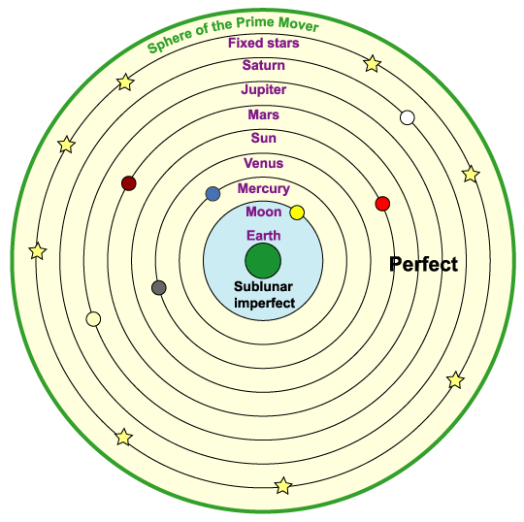
Figure 1. Aristotle’s geocentric model of the universe (Evans 312). (Point 10, boldface for a figure caption.)
2.2. An Example of Tabulation (Point 12, boldface, italics.)
We tabulate below the difficulties one may encounter in studying:
Question 1. | How can I get A?
Strategy 1. | Work hard!
Question 2. | What else can I do if I do not want to work hard?
Strategy 2. | Then try hard think about how you need not work hard. (The author’s note: a bad joke indeed)
Table 1. A monologue. (Point 10, boldface for a table caption.)
We therefore need not work hard.
2.3. More Examples
2.3.1. Ancient Greek Philosophers
In Nicolaus Copernicus, British astronomer Fred Hoyle (1915-2001) explains the relation between geocentricism and heliocentrism... (3)
2.3.2. Philosophers of the Modern Times
It is said that many philosophers of the modern times love the topic of ether.

3. Conclusion
In conclusion, we highly recommend this template to our students.
Works Cited (Start on a new page. List all the cited references in the numerical order)
- Evans, James. The History and Practice of ancient Astronomy. New York: Oxford UP, 1998. Print.
- Plato. Republic. Tr. C.D.C. Reeve. Indianapolis: Hackett, 2004. Rpt. in In Dialogue with Nature: Textbook for General Education Foundation Programme. 2nd ed. Hong Kong: Office of University General Education, 2012. 5-9. Print.
- Kuhn, Thomas. The Copernican Revolution. Cambridge, Mass.: Harvard UP, 1985. Print.
- 席泽宗主编，《世界著名科学家传记：天文学家I》，北京：科学出版社，1990。

